Easy questions

03 November 2022

20:57

1. **Actors who cooperated with their directors**

**File**: dbfs:/FileStore/shared_uploads/chaitanya.ivaturi41@gmail.com/actordirector.csv

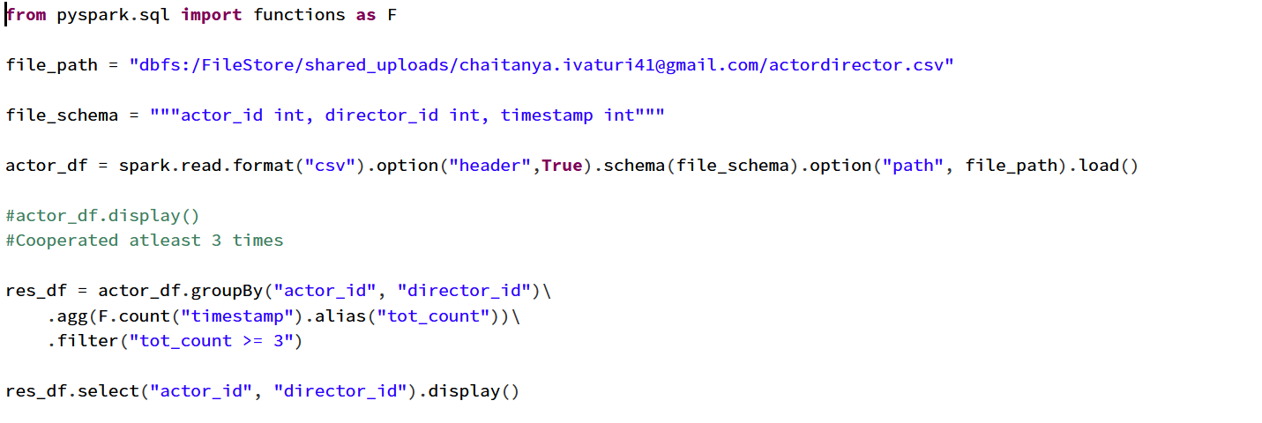

1. **Ads performance**

**File_path =** dbfs:/FileStore/shared_uploads/chaitanya.ivaturi41@gmail.com/ads.csv

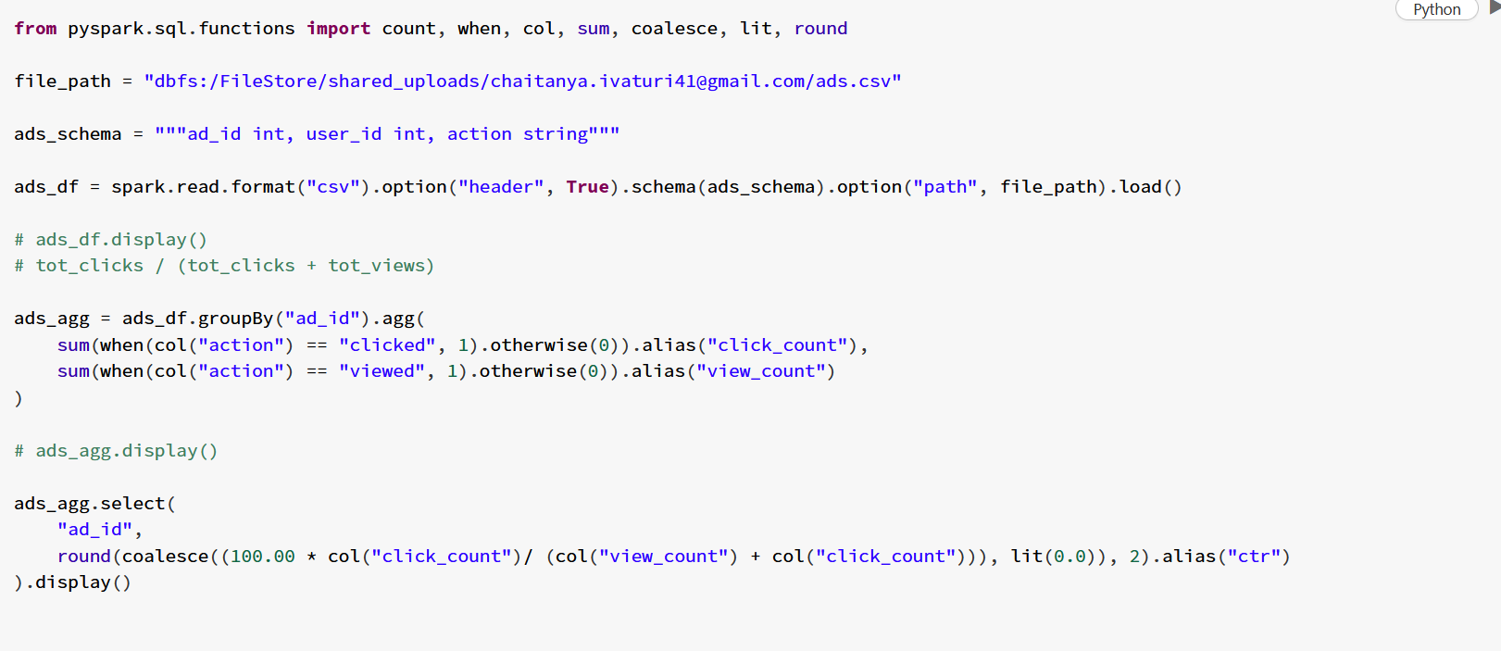

1. **Article views:**

**File_path =** dbfs:/FileStore/shared_uploads/chaitanya.ivaturi41@gmail.com/articles-1.csv

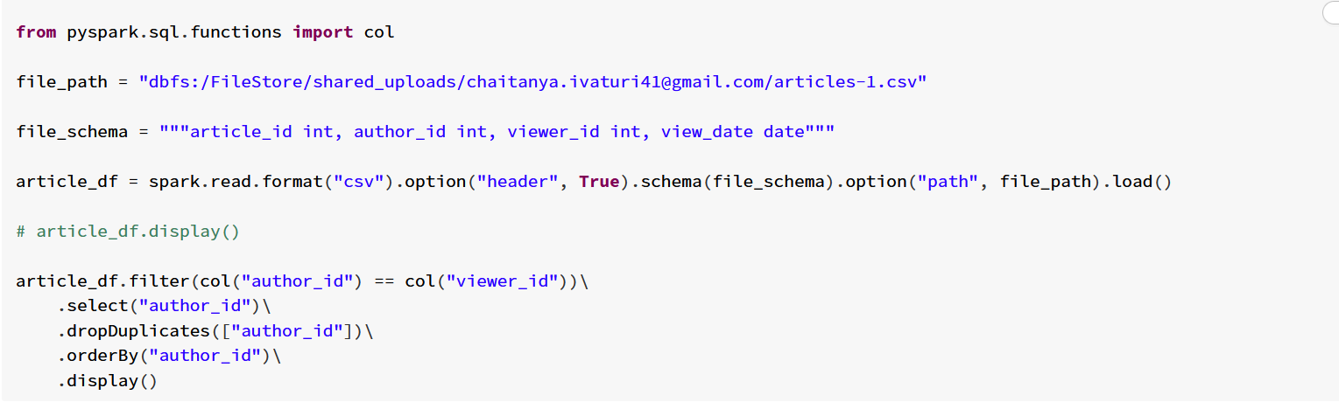

* 1. **Average Selling Price**

dbfs:/FileStore/shared_uploads/chaitanya.ivaturi41@gmail.com/unitsSold.csv

dbfs:/FileStore/shared_uploads/chaitanya.ivaturi41@gmail.com/Prices.csv

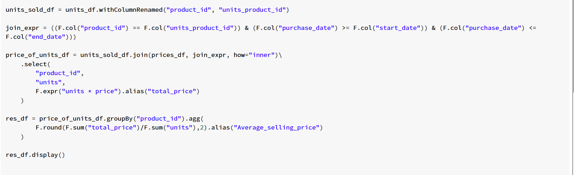

* 1. **Biggest Number**

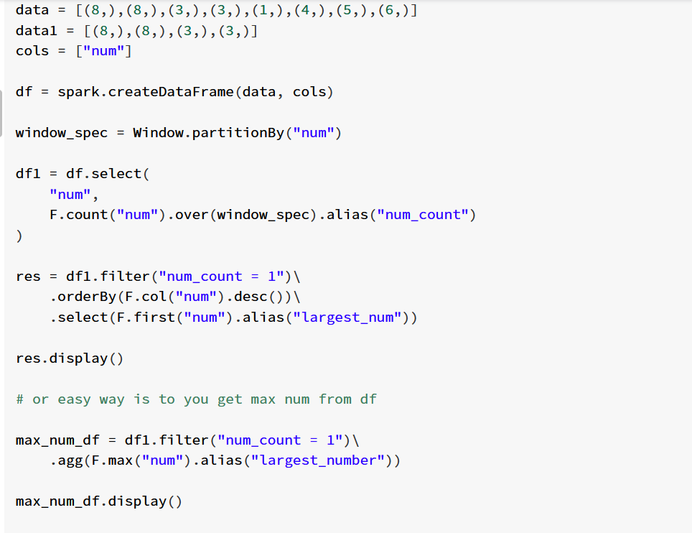

* 1. **Class more than 5 students**

file_path = "dbfs:/FileStore/shared_uploads/chaitanya.ivaturi41@gmail.com/Courses.csv"

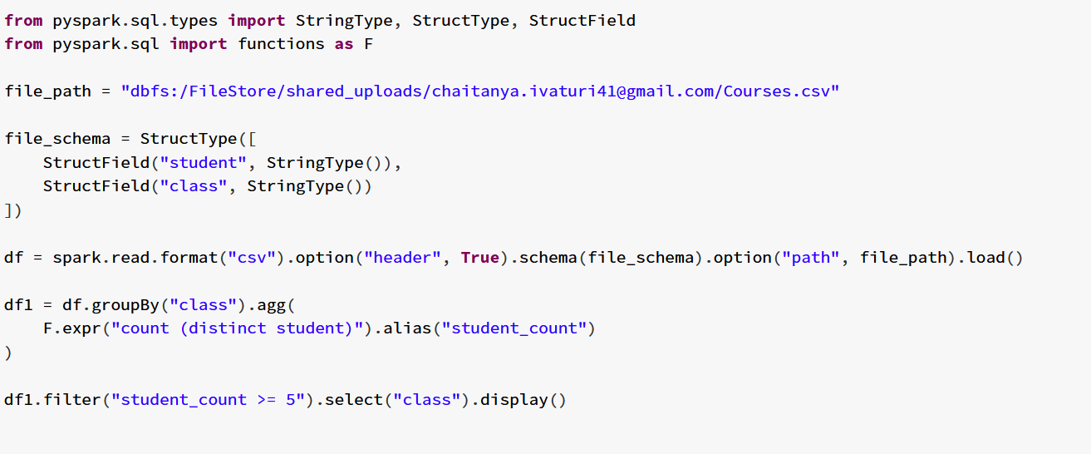

Or you can use countDistinct()

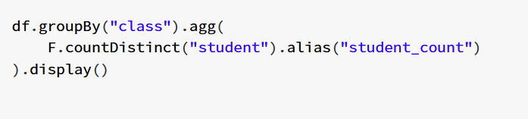

1. **Combining 2 tables:**

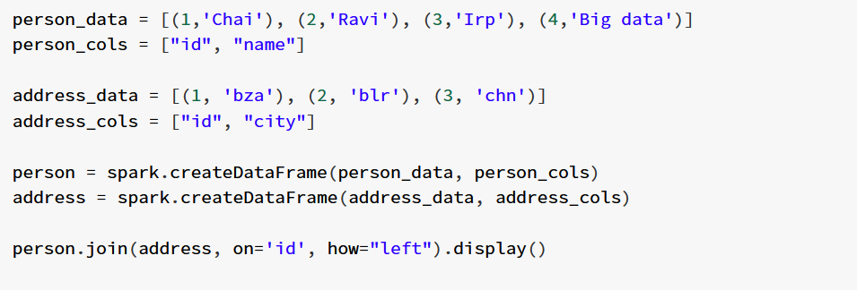

* 1. **Consecutive available seats**

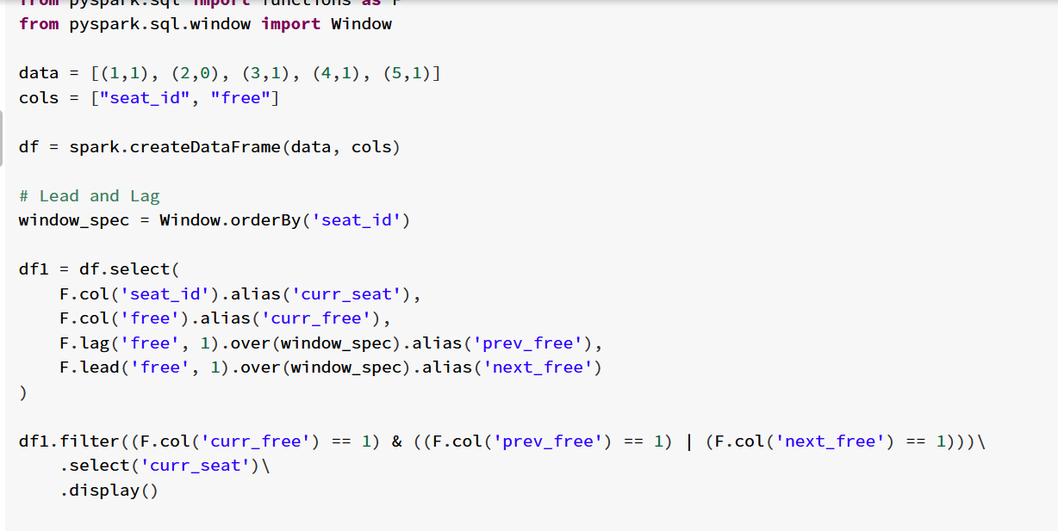

* 1. Session chart

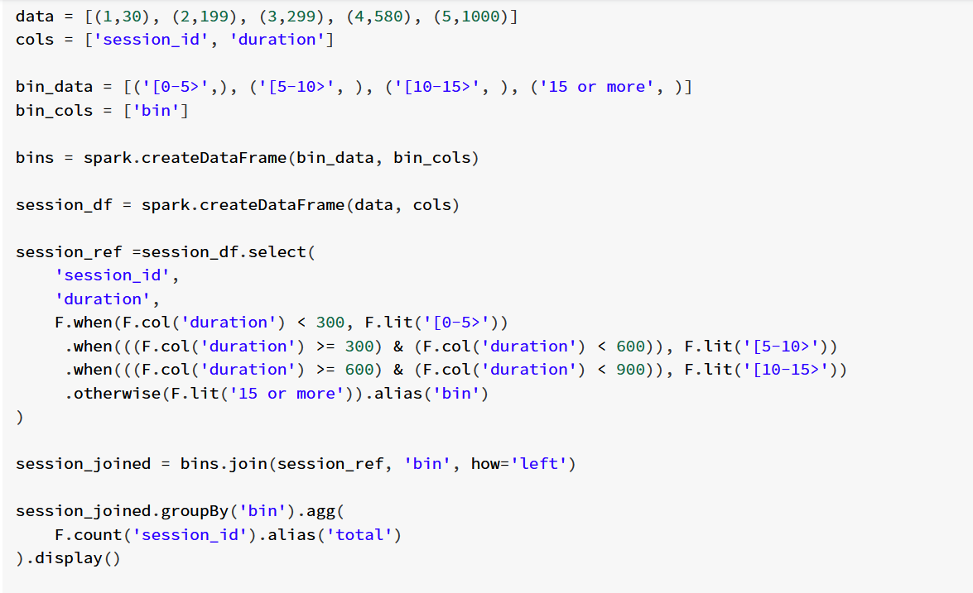

* 1. Largest number of orders

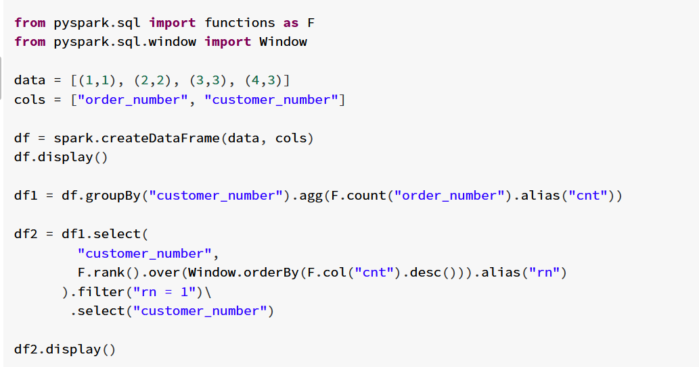

* 1. Customers who never order

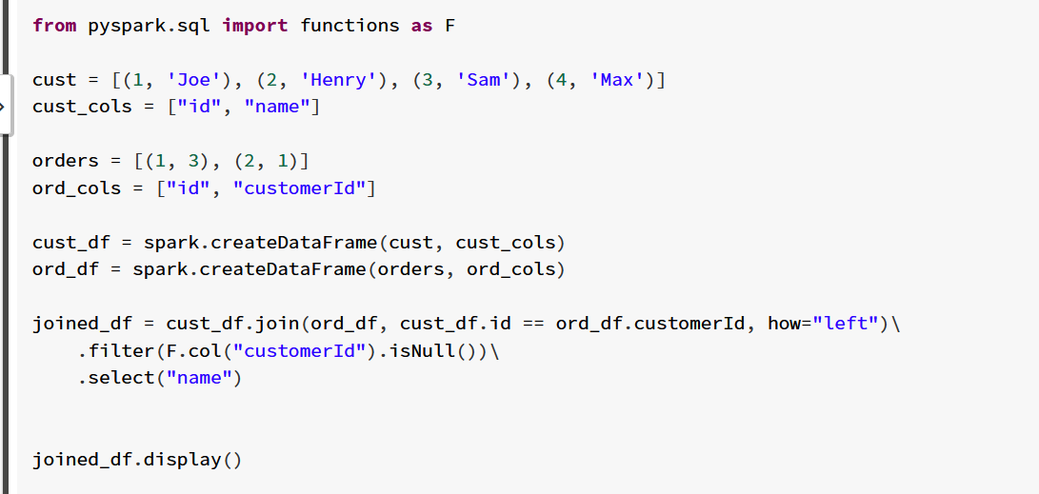

* 1. Drop duplicate emails

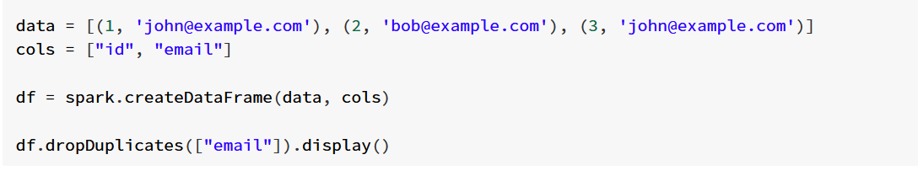

Using row_number:

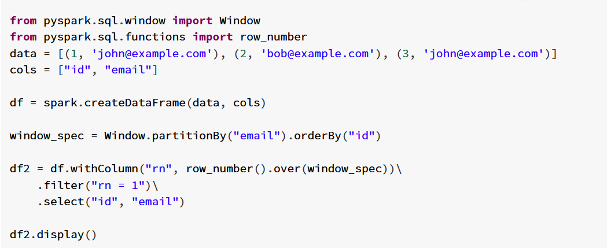

* 1. Employee Bonus

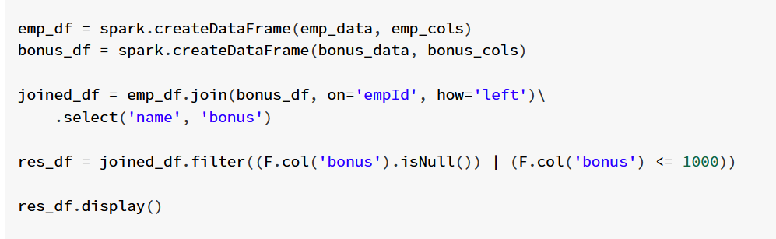

* 1. Employees salary more than managers

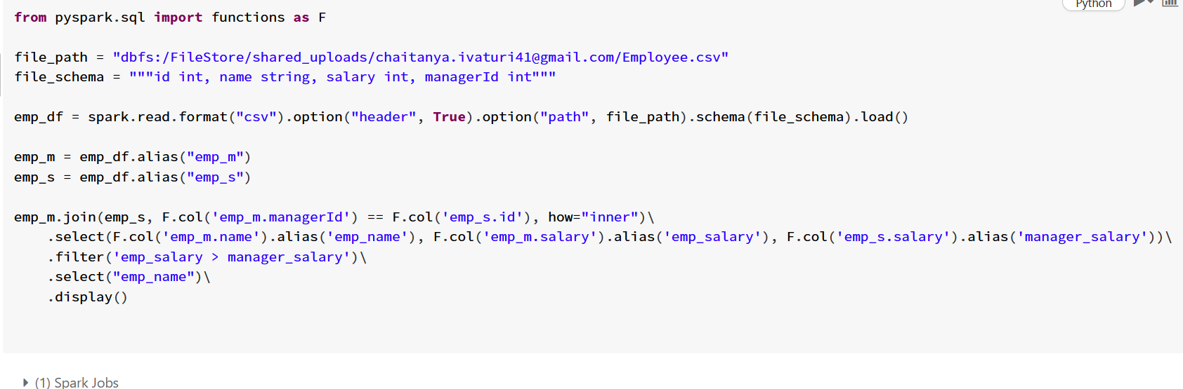

* 1. Team size

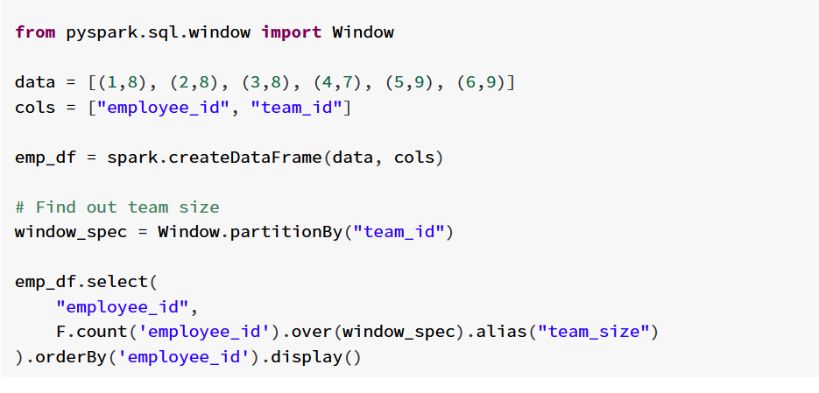

* 1. Friend Requests 1

friend_request = "dbfs:/FileStore/shared_uploads/chaitanya.ivaturi41@gmail.com/friend_request.csv"

request_schema = """sender_id int, send_to_id int, request_date string"""

request_accepted = "dbfs:/FileStore/shared_uploads/chaitanya.ivaturi41@gmail.com/request_accepted.csv"

accept_schema = """requester_id int, accepter_id int, accept_date string"""

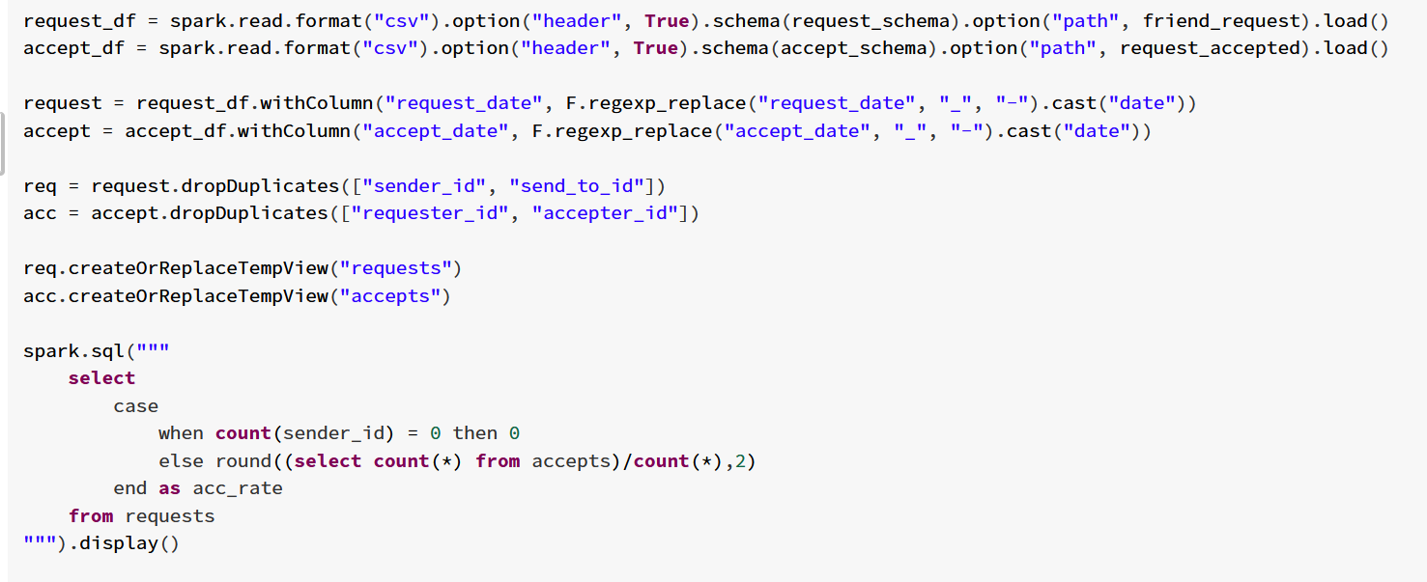

Triggering 2 actions:

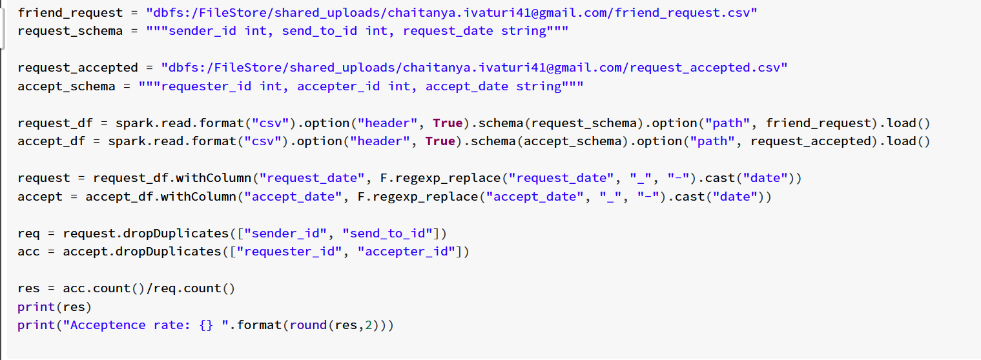

* 1. **Friendly streamed movies**

tv_program_path = "dbfs:/FileStore/shared_uploads/chaitanya.ivaturi41@gmail.com/TVProgram.csv"

tv_schema = """program_date string, content_id int, channel string"""

content_path = "dbfs:/FileStore/shared_uploads/chaitanya.ivaturi41@gmail.com/content.csv"

content_schema = """content_id int, title string, kids_content string, content_type string"""

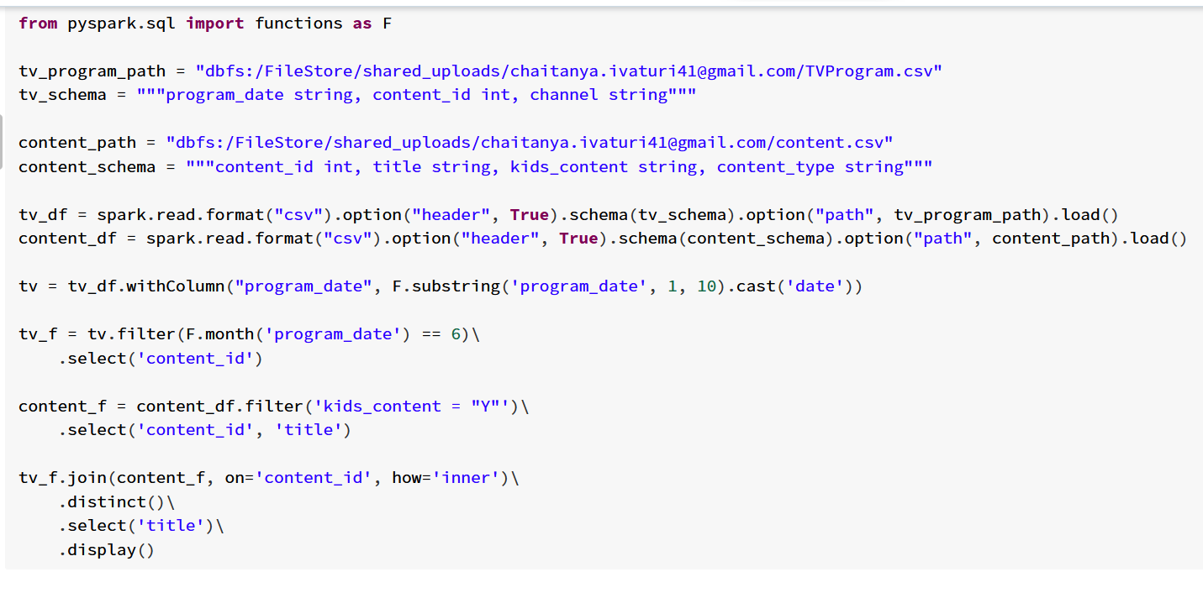

* 1. Game play Analysis 1

file_path = "dbfs:/FileStore/shared_uploads/chaitanya.ivaturi41@gmail.com/activity.csv"

file_schema = """player_id int, device_id int, event_date date, games_played int"""

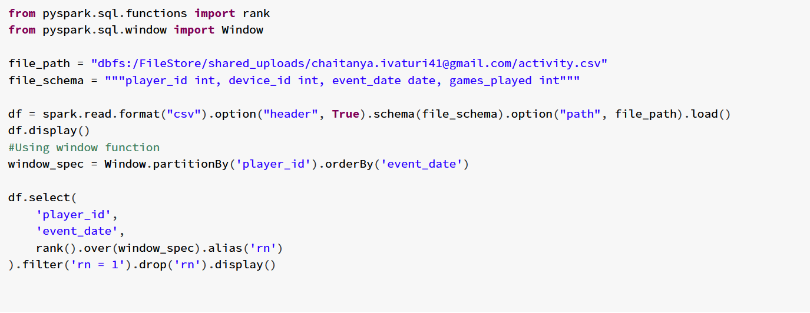

# Using groupBy

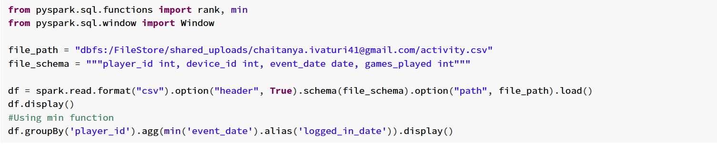

1. Game play analysis 2

Continuation of Game play analysis 1 - Same file

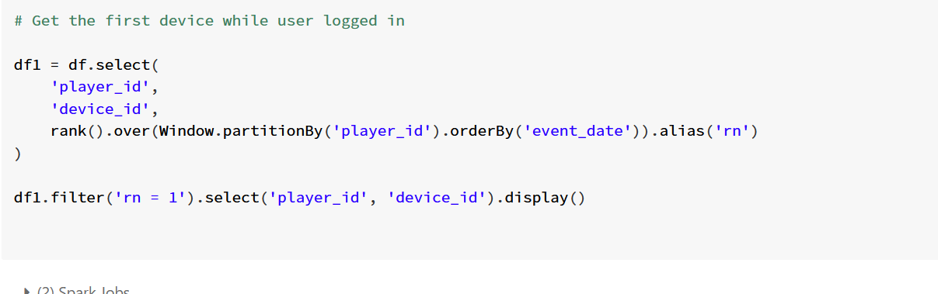

* 1. Group sold product

file_path = "dbfs:/FileStore/shared_uploads/chaitanya.ivaturi41@gmail.com/Activities.csv"

file_schema = "sell_date date, product string"

**Note: Collect list doesn’t guarantee order. It is a non-deterministic function**

**Need to check how can I achieve order using collect list**

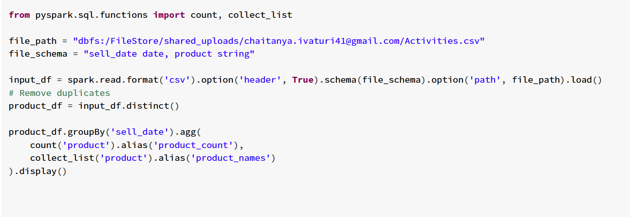

* 1. Immediate food delivery

file_path = "dbfs:/FileStore/shared_uploads/chaitanya.ivaturi41@gmail.com/Delivery.csv"

file_schema = "delivery_id int, customer_id int, order_date date, customer_pref_delivery_date date"

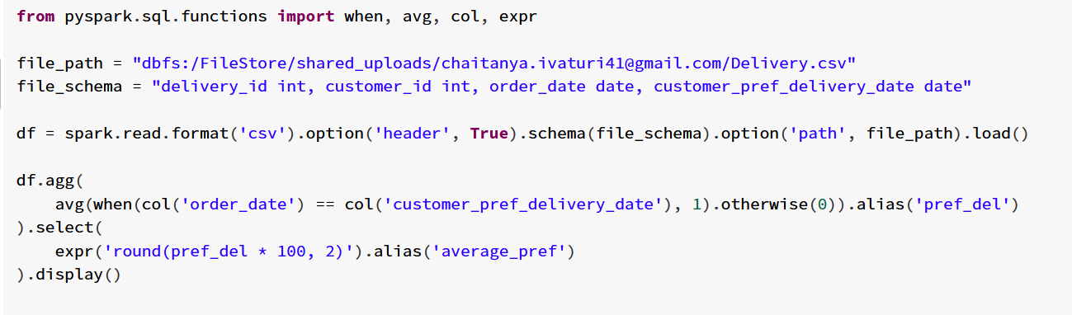

* 1. Products ordered in a period

orders_path = "dbfs:/FileStore/shared_uploads/chaitanya.ivaturi41@gmail.com/orders-3.csv"

orders_schema = """product_id int, order_date date, unit int"""

products_path = "dbfs:/FileStore/shared_uploads/chaitanya.ivaturi41@gmail.com/products.csv"

products_schema = """product_id int, product_name string, product_category string"""

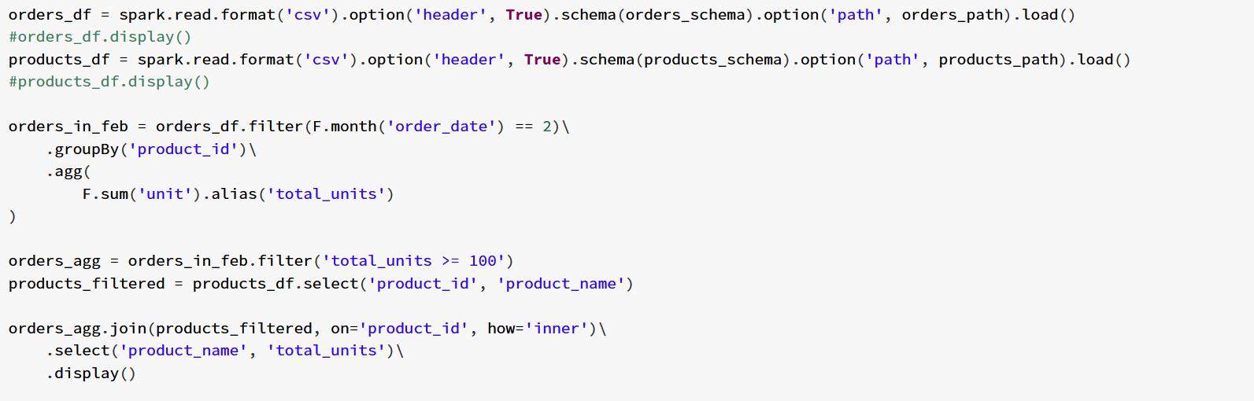

* 1. Not boring movies

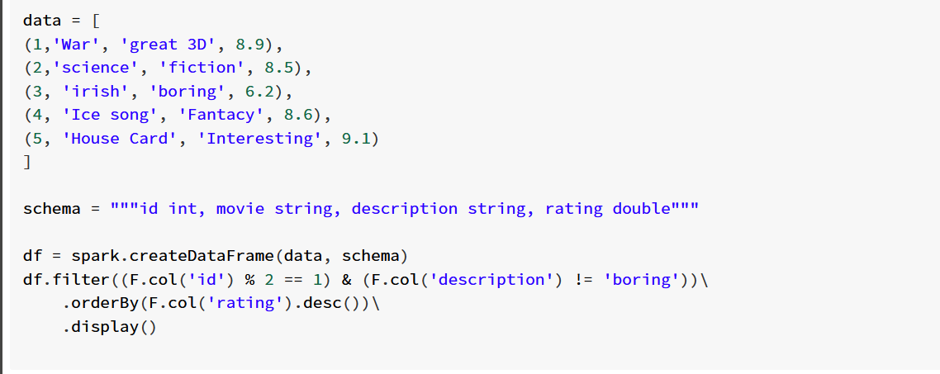

* 1. Number of comments

data = [(1, None), (2, None), (1, None), (12, None), (3,1), (5,2), (3,1), (4,1), (9,1), (10,2), (6,7)]

cols = ["sub_id", "parent_id"]

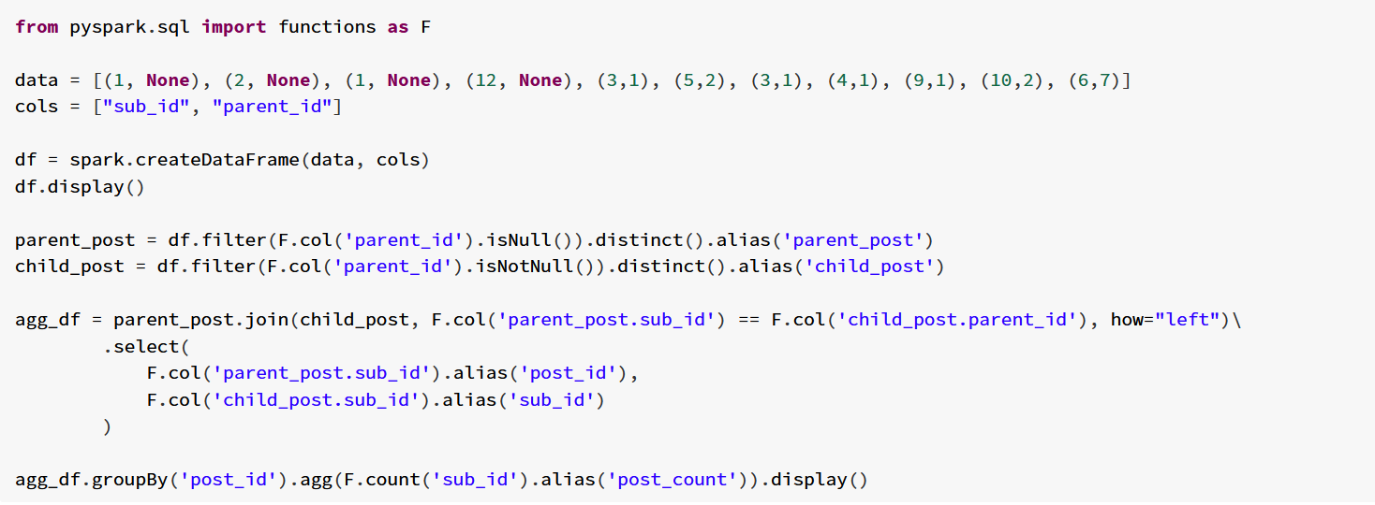

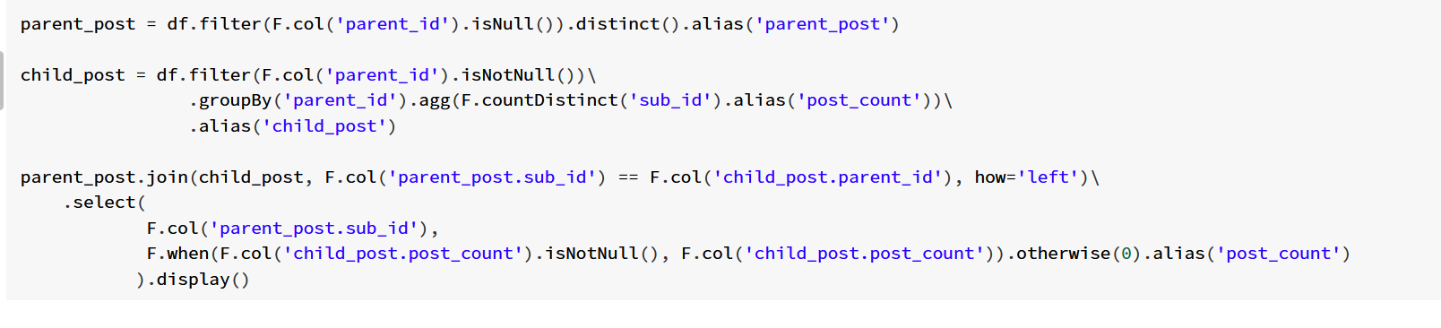

* 1. Product sales analysis 1

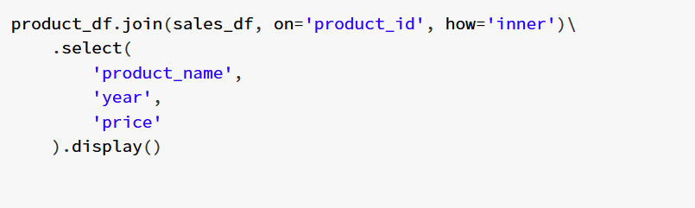

* 1. Product sales analysis 2

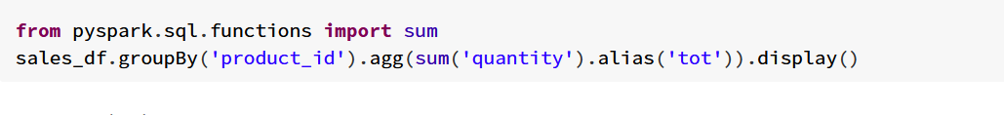

* 1. Project Employees 1

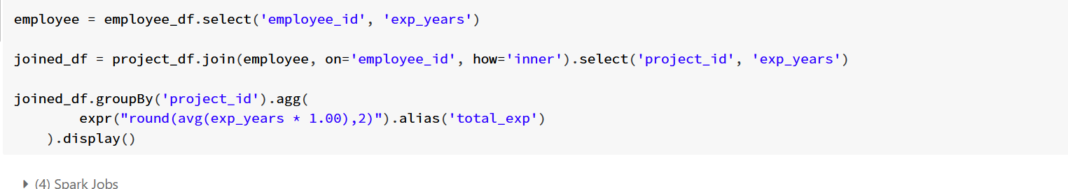

* 1. Project Employees 2

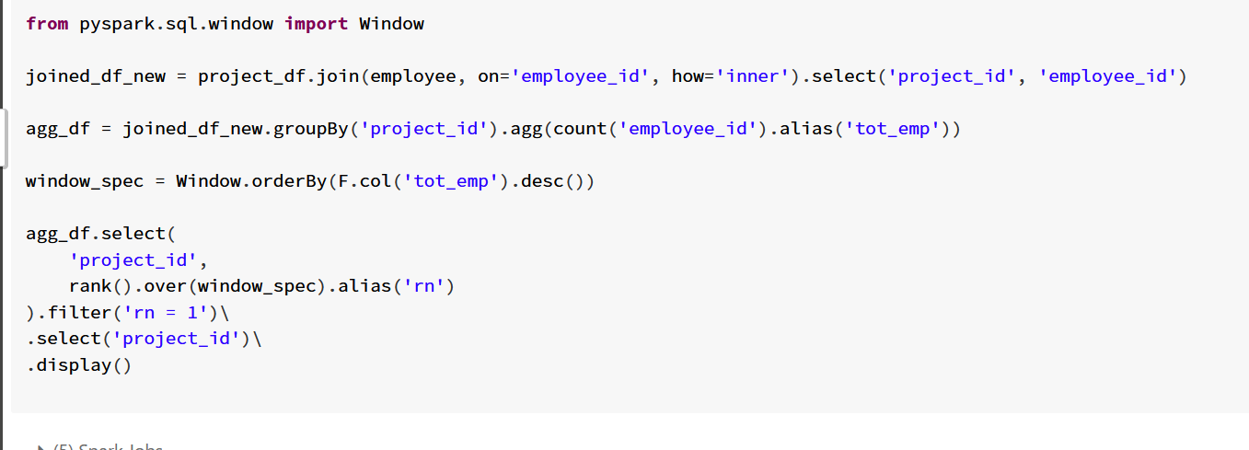

* 1. Reformat Department

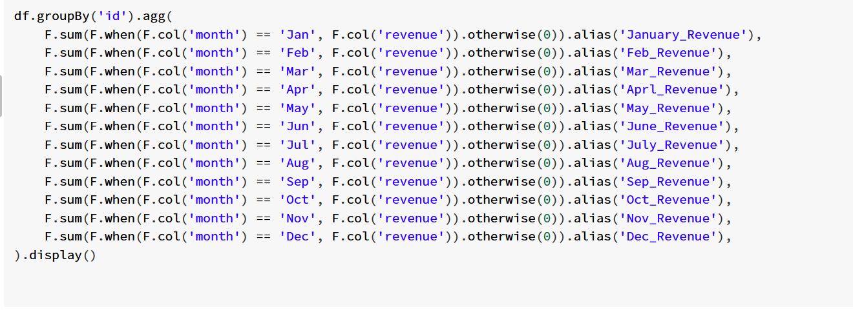

* 1. Query quality and percentage

file_path = "dbfs:/FileStore/shared_uploads/chaitanya.ivaturi41@gmail.com/Queries.csv"

file_schema = "query_name string, result string, position int, rating int"

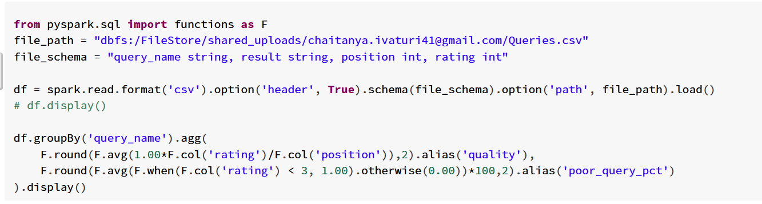

* 1. Employee unique identifier

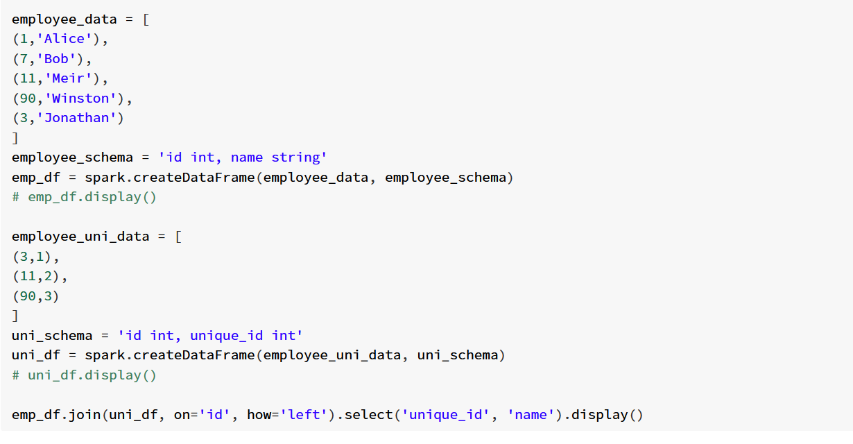

* 1. Reported posts

file_path = 'dbfs:/FileStore/shared_uploads/chaitanya.ivaturi41@gmail.com/actions_43.csv'

file_schema = """user_id int, post_id int, action_date date, action string, extra string"""

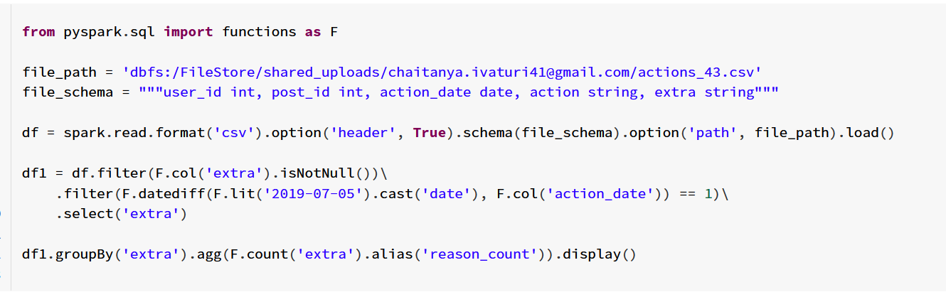

* 1. Rising Temperature

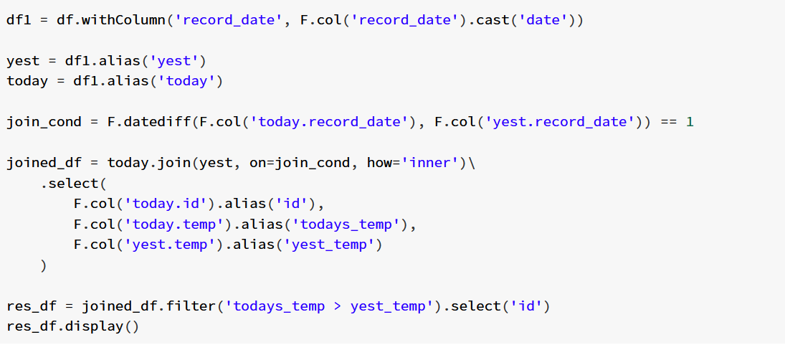

* 1. Sales analysis 1 - **Applying window over entire dataframe will cause data to move to single partition. How to tackle this?**

product_path = 'dbfs:/FileStore/shared_uploads/chaitanya.ivaturi41@gmail.com/product.csv'

product_schema = '''product_id int, product_name string, unitprice int'''

sales_path = 'dbfs:/FileStore/shared_uploads/chaitanya.ivaturi41@gmail.com/sales.csv'

sales_schema = '''seller_id int, product_id int, buyer_id int, sale_date date, quantity int, price int'''

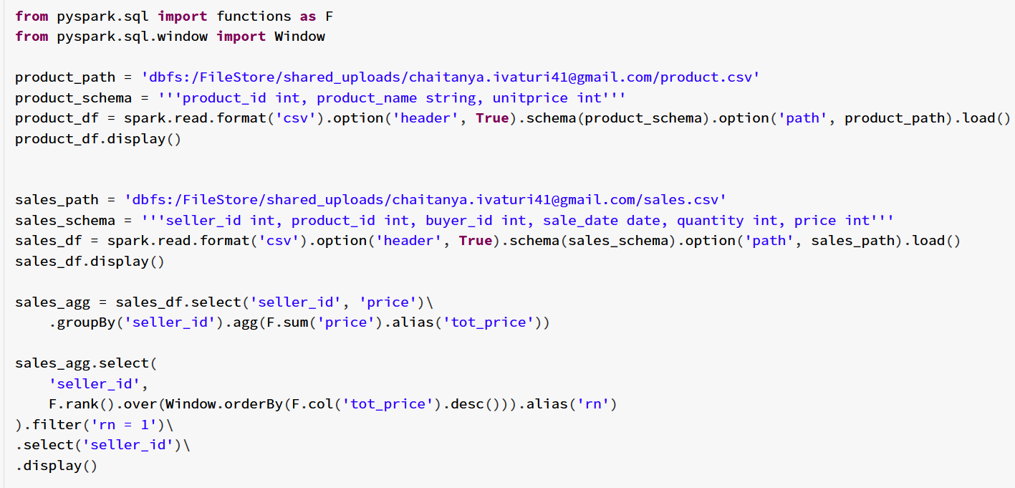

* 1. Sales Analysis 2

Dataset - sales-3

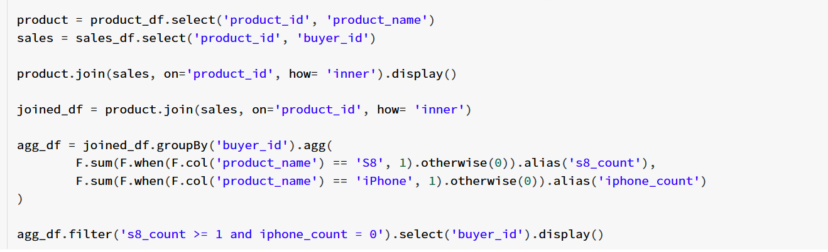

* 1. Sales Analysis 3

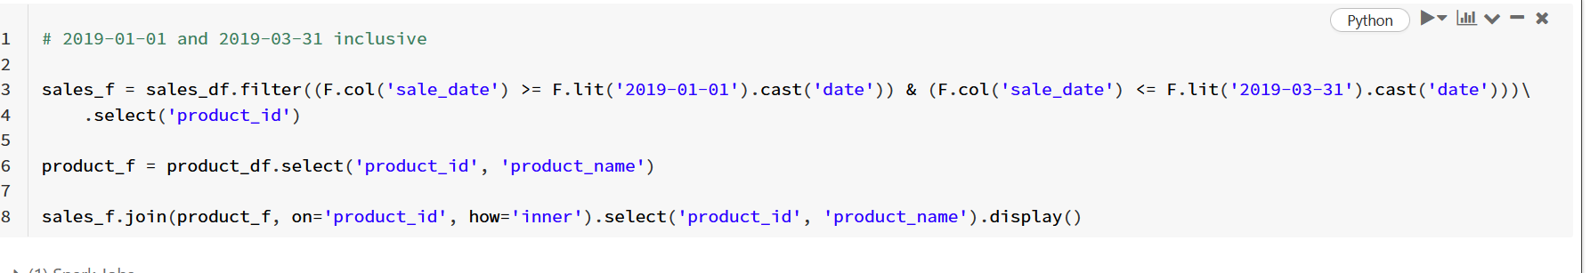

* 1. Sales person

sales_path = 'dbfs:/FileStore/shared_uploads/chaitanya.ivaturi41@gmail.com/salesperson-1'

sales_schema = '''sales_id int, name string, salary int, commission_rate int, hire_date string'''

sales_df = spark.read.format('csv').option('header', True).schema(sales_schema).option('path', sales_path).load()

company_path = 'dbfs:/FileStore/shared_uploads/chaitanya.ivaturi41@gmail.com/company'

company_schema = '''com_id int, name string, city string'''

company_df = spark.read.format('csv').option('header', True).schema(company_schema).option('path', company_path).load()

orders_path = 'dbfs:/FileStore/shared_uploads/chaitanya.ivaturi41@gmail.com/orders_12.csv'

orders_schema = '''order_id int, order_date string, com_id int, sales_id int, amount int'''

orders_df = spark.read.format('csv').option('header', True).schema(orders_schema).option('path', orders_path).load()

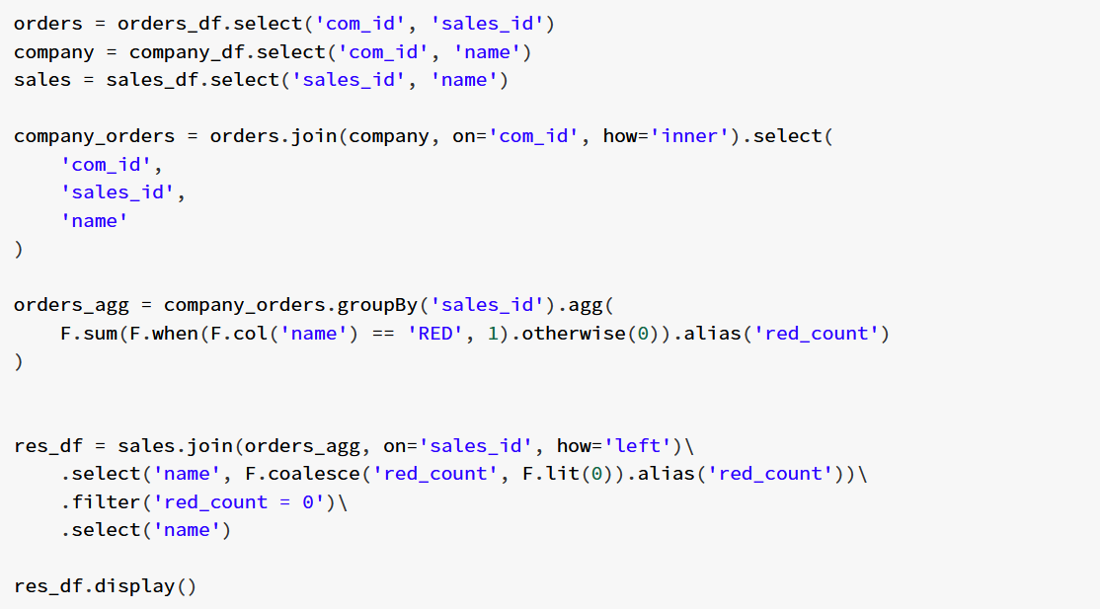

* 1. Second highest salary

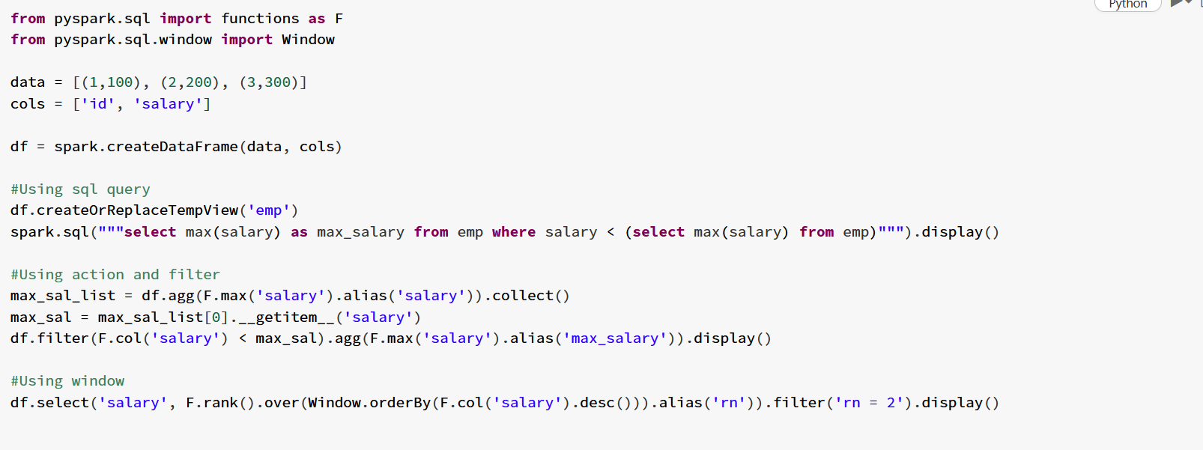

* 1. Shortest Distance

Which is best ? Sort or cross join

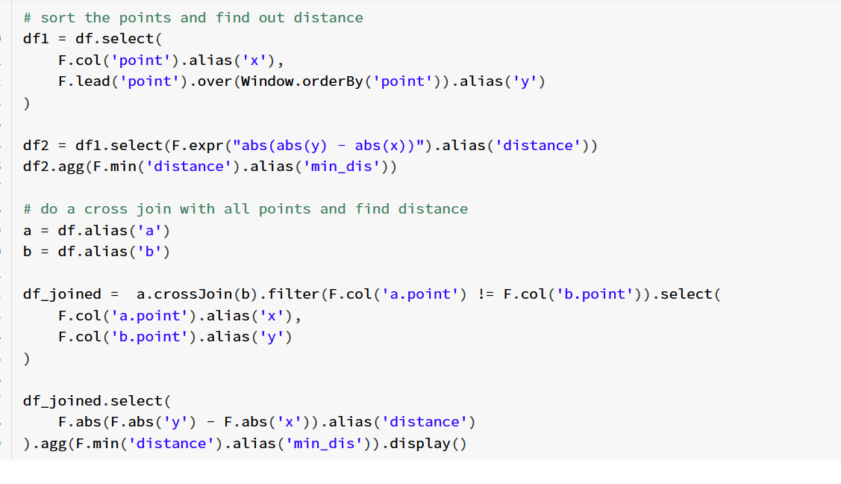

* 1. Student and Examinations

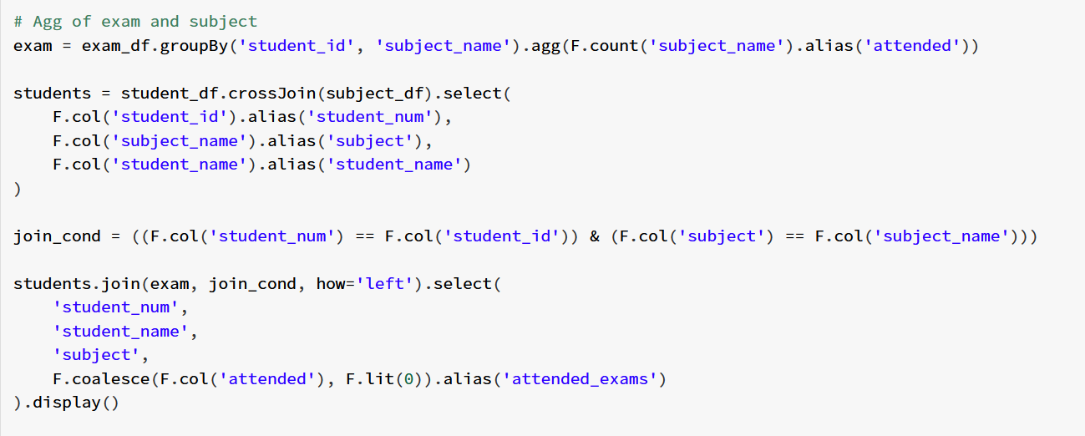

* 1. Invalid Departments

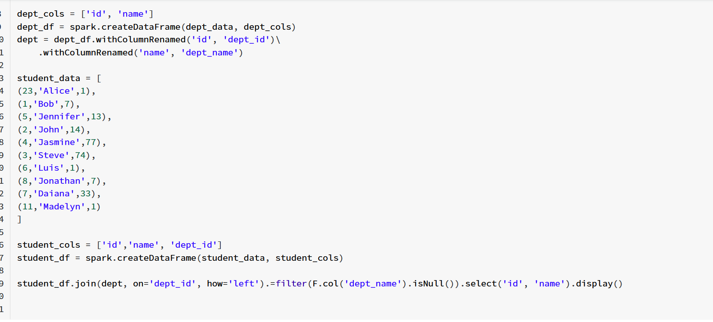

* 1. Swap salary

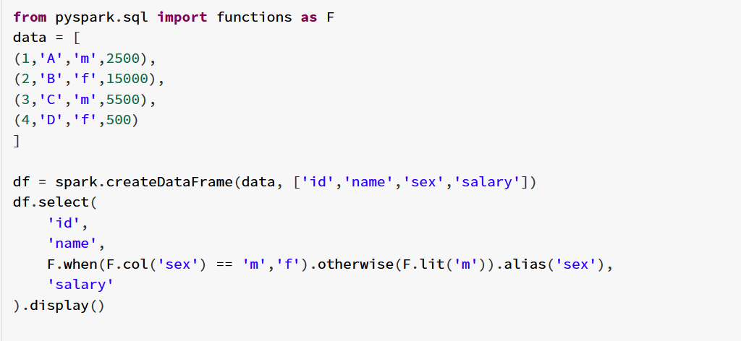

* 1. Top Travellers

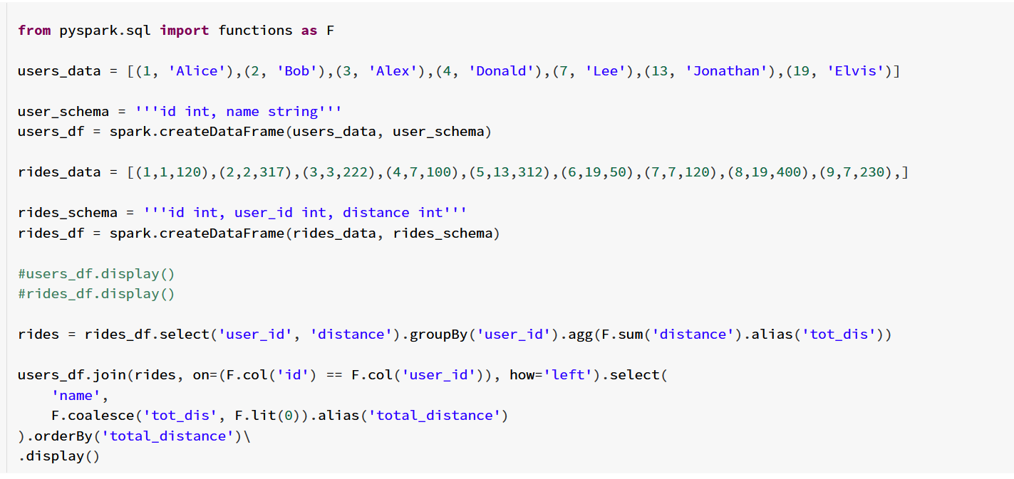

* 1. Triangle judgement

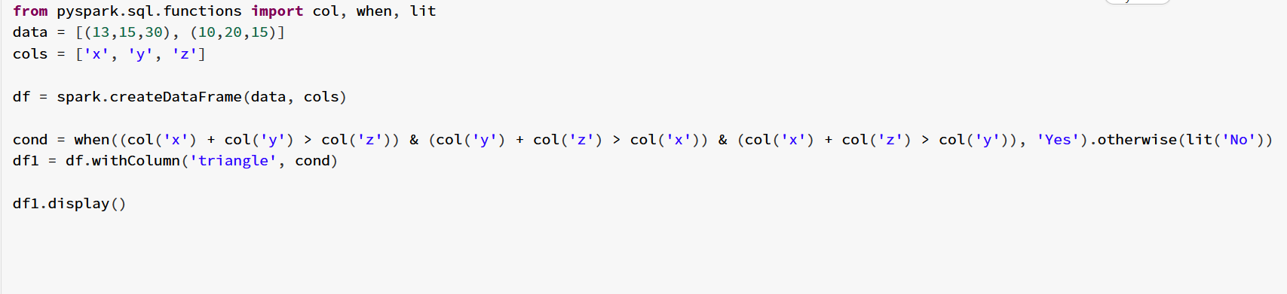

* 1. User activity in 30 days 2 - **Any other way to optimize this? Window or groupBy?**

file_path = 'dbfs:/FileStore/shared_uploads/chaitanya.ivaturi41@gmail.com/activity_35-1.csv'

activity_schema = '''user_id int, session_id int, activity_date date, activity_type string'''

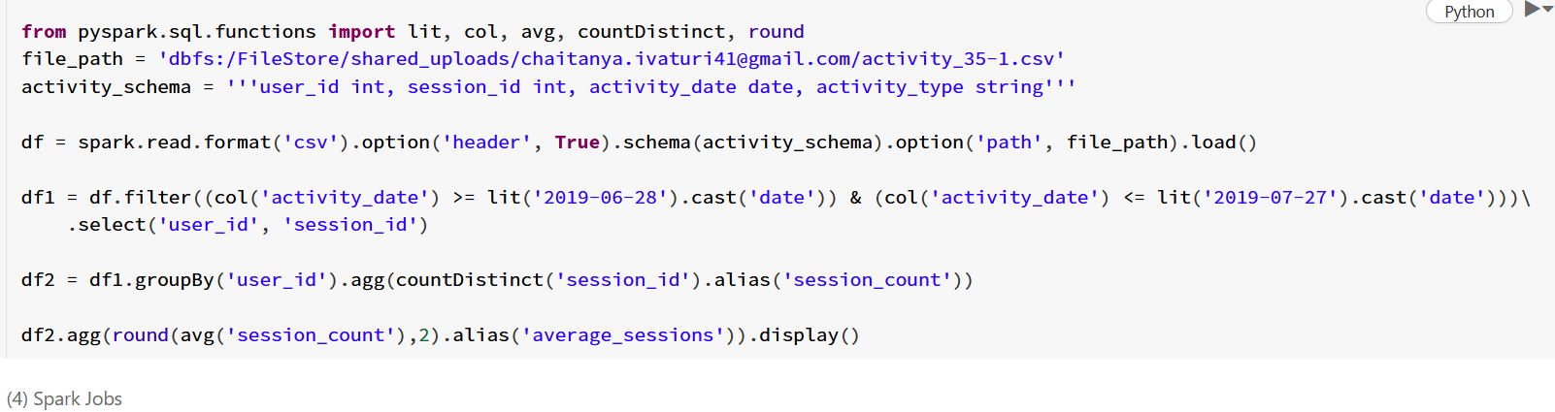

* 1. User activity in 30 days 1

Same data as above

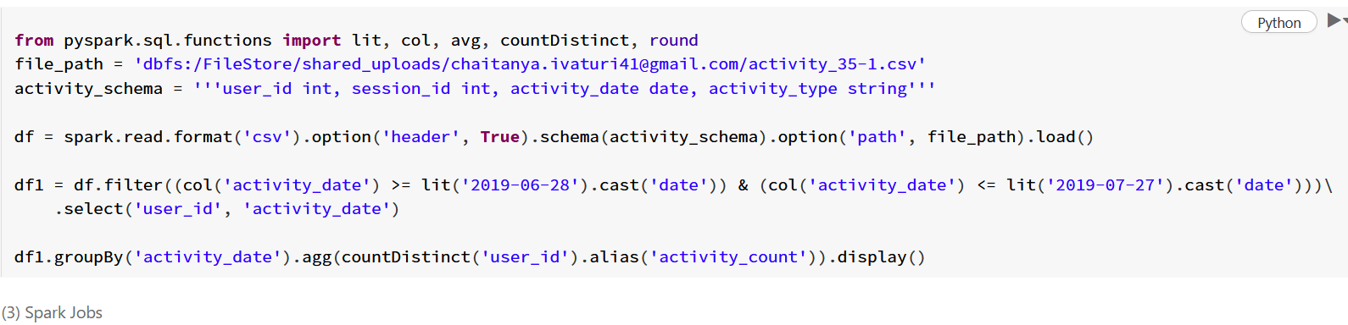

* 1. Weather type

country_path = "dbfs:/FileStore/shared_uploads/chaitanya.ivaturi41@gmail.com/countries.csv"

country_schema = """country_id int, country_name string"""

weather_path = "dbfs:/FileStore/shared_uploads/chaitanya.ivaturi41@gmail.com/weather.csv"

weather_schema = """country_id int, weather_state int, day date"""

